Materials Testing: Stress and Fatigue Analysis

Ryan Kim
Department of Mechanical and Aerospace Engineering
Rutgers University, Piscataway, New Jersey 08854

To find the material properties of aluminum, brass, and copper, this lab experiment uses two machines to split selected materials in half while recording various measurements. The first machine used is the PASCO Material Testing System which pulls a thin strip of the metal apart with axial force (tension) at a slow constant rate, meanwhile recording the amount of force applied, the strain, and the time elapsed. The calculated Young’s Modulus values of the aluminum, brass, and copper are (respectively) 14.747 GPa, 27.265 GPa, and 21.011 GPa. This makes brass the most elastic material, followed by copper and then aluminum. The second machine used is a Rotary Fatigue Machine which counted the amount of spin cycles a cylindrical piece of Aluminum Alloy 2011 T6 could withstand before fracturing under rotating stress. This was done using two different loads, at 50N and 60N, both with a spin cycle rate of 63 Hz. Under both conditions, the aluminum pieces snapped before reaching 10^5 cycles, resulting in an S-N Curve with no fatigue limit.

INTRODUCTION
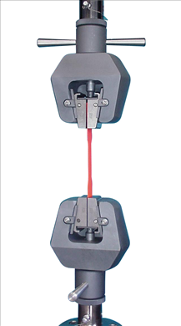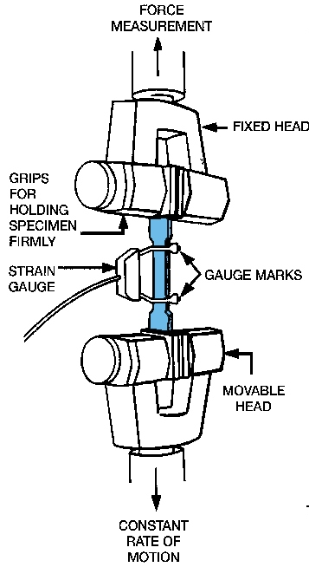
Figure 1. Schematic of Tensile Testing Machine, PASCO Material Testing System (MTS)
Above is an illustration that shows two clamps, pulling a strip of metal apart (tension) with a constant rate of relative displacement. For every 0.2 second, the applied force, displacement, and speed are recorded onto a spreadsheet. The cross sectional area at the middle of the metal strip, normal to the axis of tension, is measured using Vernier Calipers.

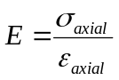 [1]
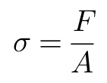
[2]

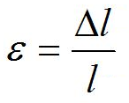
[3]

In the above equations, it is shown that stress can be calculated by dividing the force by the cross sectional area previously mentioned. The initial length of the narrow section of the metal strip is known also from the calipers, and so strain is simply the displacement divided by the initial length. Then the Young’s Modulus of Elasticity, E, is calculated by stress divided by strain.

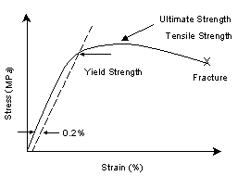
Figure 2. Stress/Strain Diagram shows Ultimate Strength, Fracture Stress, and the 0.2% shifted linear slope of elastic region indicating the Yield Strength
In Figure 2, Stress is plotted over Strain, giving a visualization of the behavior of the material before it snaps. The initial constant slope before it starts to curve is the Young’s Modulus; this straight proportional line goes from 0 to its Proportional Limit where the constant slope ends and starts to strain more per change in stress. This is the reversible, elastic deformation portion of the stress/strain curve, and the Young’s Modulus describes the elastic linear ratio of increase in stress per increase in strain.
Once the line starts to curve, it is past its Proportional Limit. Taking the same initial slope, and shifting its strain .2% to the right (adding 0.002 to the strain), a line is drawn that can intersect the curve at where it is estimated to be the point of yielding. The measured stress at this position is the “0.2% Conventional Yield Stress”, which is a good estimate of the actual Yield Stress. It is difficult to choose where exactly on the curve the material starts to plastically (irreversibly) deform, so the 0.2% approximation is useful.
The Ultimate Stress is the highest point along the stress curve, meaning the very maximum tensile stress the material undergoes before fracturing. When the data shows there is 0 force being applied at the end of the curve, it is an indication that the metal is no longer opposing the tension because it has split in half, and this is the point of Fracture Stress. The metal strip, as implied by the increase in strain and displacement, stretches to a maximum change in length before fracture occurs; this change in length is the Elongation to Fracture. It is a part of the recorded data.
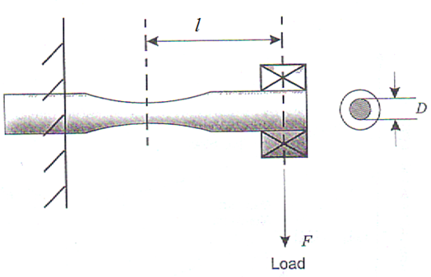
The Modulus of Resilience is a measurement of how much accumulated stress the material can take while staying elastic. Therefore, it is the area under the stress/strain curve from 0 until the Proportional Limit. Using the trapezoid rule for integration directly from the data, taking the areas of each increment of strain with corresponding averaged stress pairs, the area under the stress/strain curve can be determined. This is used for both the entire curve (from 0 to fracture) and for the elastic region. The area in the elastic region is equal to the Modulus of Resilience. The area under the entire curve is the Modulus of Toughness, the accumulated amount of stress over the full strain, from 0 to fracture. Toughness is the amount of work per unit volume done on the material before it reaches failure. Similarly, the Modulus of Resilience can be described as the work per unit volume done before causing irreversible strain.
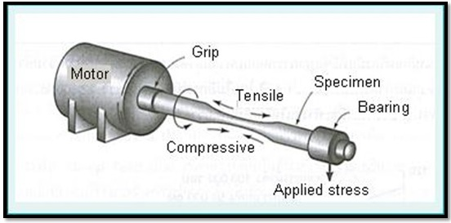
Figure 3. Rotary Fatigue Machine
A cylindrical piece of Aluminum Alloy 2011 T6 is placed into a Rotary Fatigue Machine matching the schematic and shape of Figure 3. With a constant applied force for each trial, the aluminum rotates, thus undergoing a constantly reversing stress. As shown in the figure, the applied stress causes a downward torque that has the bottom side in compression and the upper side in tension. While it rotates, the machine counts the amount of rotations (or cycles) before fatigue causes fracture of the aluminum. Fatigue is characterized by failure due to repeated and fluctuating stresses. The Fatigue Limit (or Endurance Limit) is the maximum amount of stress a material can withstand through (10^6)+ cycles (or virtually infinite cycles).
In this experiment, there are 2 different fatigue tests (applied to 2 cylinders of the same aluminum alloy), one with a 50 N load and one with a 60 N load. They both cycle at a rate of 63 Hz. Below is the schematic of measurements, along with the useful equation.

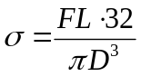 [4]

Figure 4 and Eq 4. Aluminum’s Measurements and the standard bending equation for the Fatigue Test.
Solving for the 2 stresses in the bending equation, they are plotted on a linear vertical axis along a logarithmic horizontal axis indicating the N-cycles at which failure occurred. This is the S-N Curve.

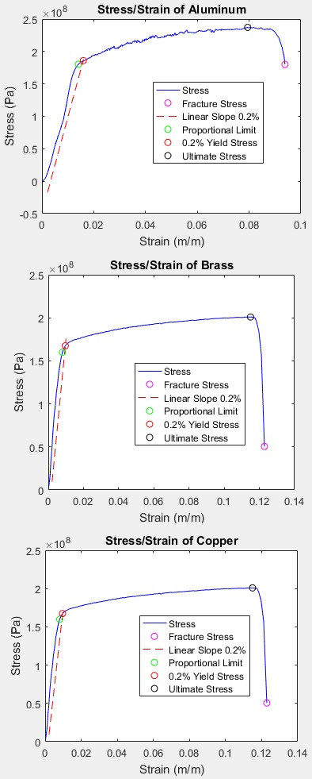
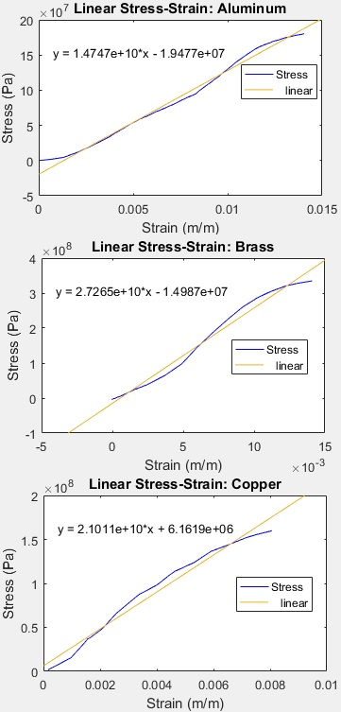
RESULTS AND DISCUSSION

Graph 1. Stress/Strain Plots for Tensile Test. Full data on left, Elastic portion on right.

In the plots above, we see the stress/strain curves of Aluminum, Brass, and Copper from the tensile test. The linear interpolations on the right side give the elastic slopes, the Young’s Modulus. The left side shows the full curves plotted from 0 to fracture, and through graphical analysis, many critical points are identified visually in the plot. Through keeping record of indices in Matlab, I found the numerical values for them:

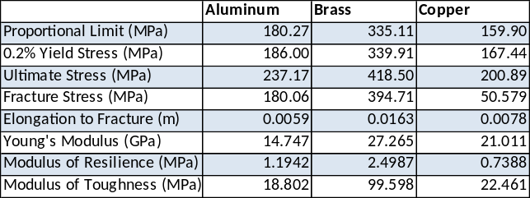
Table 1. Critical values of Tensile Testing calculated from Matlab analysis.
In the table, it is seen that Brass is the toughest and most resilient. It endures the highest tensile stress before fracture, and it stretches out the most distance too giving it the most strain before failure. Brass also stays elastic and starts to yield at about twice as much stress than aluminum and copper do. Brass has the highest ultimate stress value, therefore having the highest tensile strength, followed by aluminum and then copper. With Brass having a calculated E = 27.265 GPa, it is the most elastic, followed by copper and then aluminum. However, aluminum has a higher yield stress than copper.

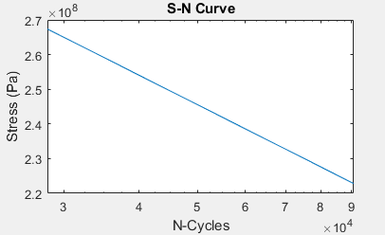
Graph 2. Aluminum S-N Curve from Fatigue Test. Logarithmic X-axis counting rotations. Stress Calculated from Eq 4.
The Stress vs. Cycles Plot shows a line between two points of fatigue failure, which are the only given data from the experiment of two trials. Since the data stops at less than 10^5 cycles, and there is no flat sloped stress that continues without failure beyond 10^6 cycles, there is no fatigue limit to be found from this. We did not find a maximum stress at which endless/continuous rotations could be made without fracture.

CONCLUSIONS
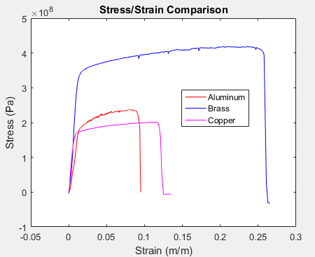
Graph 3. Comparison of Stress/Strain Curves for Tensile Testing.
From the graph comparing the stress/strain curves of the three metals that lead to fracture, it is shown that brass would be very good for a machine part that must withstand a lot of tensile stress before fracturing or even yielding to plastic deformation. Brass and copper have a very high modulus of elasticity, and they are very rigid. Aluminum and brass both can withstand a good amount of strain before yielding, making them good candidates for ductile materials. The overall toughness of copper and aluminum are similar, brass still being the highest. Copper and aluminum are malleable compared to brass, so they would be used for things like wires, cans, and packaging. The tensile testing, along with graphing, gave a lot of insight into the properties of these three metals. The fatigue testing showed that aluminum alloy can reach failure from loads of 50 N and 60 N with their respective calculated bending stress values at 222.82 MPa and 267.38 MPa, failing at 90,665 and 28,202 cycles respectively. With only 2 data points, a fatigue limit could not be determined. However, the given minimum yield stress was 220 MPa which was very closely under the calculated values, so validity is held in this experiment.

REFERENCES

[1] Lab Manual
[2]https://pursuitengineering.blogspot.com/2017/01/fatigue-testing.html.

All Calculations done on Matlab:
Materials Lab - Plots 1
Plot Stress/Strain Comparison of All 3 2
Plot Aluminum 2
Plot Aluminum Linear Portion 3
Plot Brass 4
Plot Brass Linear 5
Plot Copper 6
Plot Copper Linear 7
Critical Stress Points 8
Area under SS Curve 9
2 Fatigue Cylinders - Bending Stress 10
S-N Curve 10

Materials Lab - Plots
%-->First run Aluminum, Brass, Copper .m-files
% These include data on time(t),force(f),position(pos),and velocity(vel)
% 'tA' means time of Aluminum, posB is position of Brass, fC is force of
% Copper, etc...
% t:seconds
% pos:meters
% f:Newtons
% vel:mm/min
% v:m/s
% Velocity in m/s
vA = velA*(.001/60);
vB = velB*(.001/60);
vC = velC*(.001/60);
% Height in m
heightA = 0.0631952;
heightB = 0.0631952;
heightC = 0.0632460;
% Areas in m^2
areaA = 4.709668*10^-6;
areaB = 4.580636*10^-6;
areaC = 4.903216*10^-6;
% Stress in Pascals
% Strain (dL/L0)
stressA = fA/areaA;
strainA = posA/heightA;
stressB = fB/areaB;
strainB = posB/heightB;
stressC = fC/areaC;
strainC = posC/heightC;

Plot Stress/Strain Comparison of All 3
plot(strainA,stressA,'r-',strainB,stressB,'b-',strainC,stressC,'m-');
legend('Aluminum','Brass','Copper')
title('Stress/Strain Comparison')
xlabel('Strain (m/m)')
ylabel('Stress (Pa)')
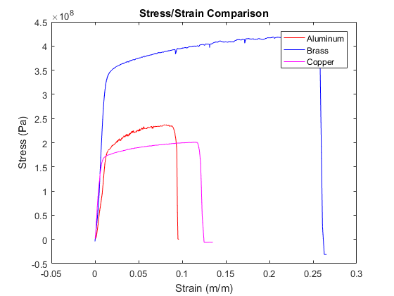

Plot Aluminum
Fracture at index i = 392 Ultimate at i = 350 Proportional Limit at i = 54 0.2% Yield at i = 64
linA = (1.4747e+10)*strainA(1:54)-1.9477e+07;
% This 'linA' is the linear elastic curve-fit line
% In the plot function below, it is plotted .002 to the right (.2%)
% All targetted points and indices are chosen graphically and accurate to
% the data.
plot(strainA(1:392),stressA(1:392),'b',strainA(392),stressA(392),'mo',[strainA(1:54)+.002],linA,'r--',strainA(54),stressA(54),'go',strainA(64),stressA(64),'ro',strainA(350),stressA(350),'ko')
legend('Stress','Fracture Stress','Linear Slope 0.2%','Proportional Limit','0.2% Yield Stress','Ultimate Stress')
title('Stress/Strain of Aluminum')
xlabel('Strain (m/m)')
ylabel('Stress (Pa)')
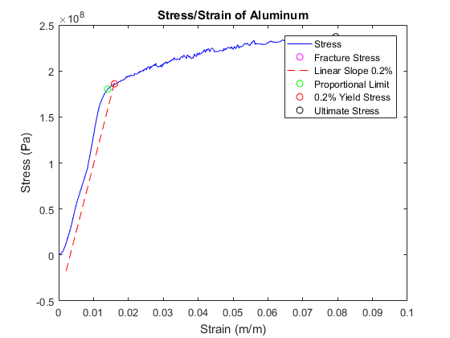

Plot Aluminum Linear Portion
Proportional Limit at i = 54
linA = (1.4747e+10)*strainA(1:54)-1.9477e+07;
plot(strainA(1:54),stressA(1:54),'b')
title('Linear Stress-Strain: Aluminum')
legend('Stress')
xlabel('Strain (m/m)')
ylabel('Stress (Pa)')
youngA = 1.4747e+10; % Here is the Young's Modulus, the slope of linA
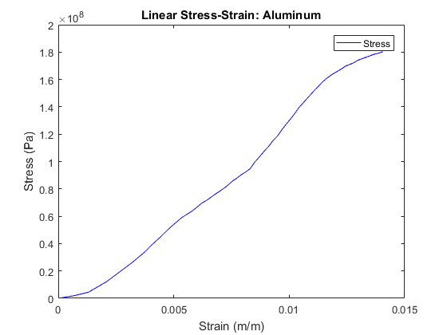

Plot Brass
sB = stressB(1:235);
eB = strainB(1:235);
% Fracture at i = 235
% Ultimate at i = 196
% Proportional Limit i = 15
% 0.2% Yield at i = 16
linB = (2.7265e+10)*eB(1:15)-1.4987e+07;
plot(eB,sB,'b',eB(235),sB(235),'mo',[eB(1:15)+.002],linB,'r--',eB(15),sB(15),'go',eB(16),sB(16),'ro',eB(196),sB(196),'ko')
legend('Stress','Fracture Stress','Linear Slope 0.2%','Proportional Limit','0.2% Yield Stress','Ultimate Stress')
title('Stress/Strain of Brass')
xlabel('Strain (m/m)')
ylabel('Stress (Pa)')
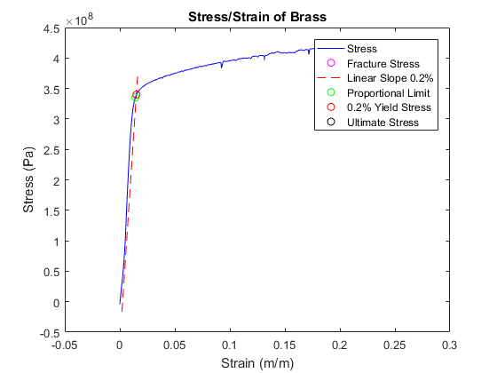

Plot Brass Linear
linB = (2.7265e+10)*eB(1:15)-1.4987e+07;
plot(eB(1:15),sB(1:15),'b')
title('Linear Stress-Strain: Brass')
legend('Stress')
xlabel('Strain (m/m)')
ylabel('Stress (Pa)')
youngB = 2.7265e+10; % Young's Modulus, slope of linB
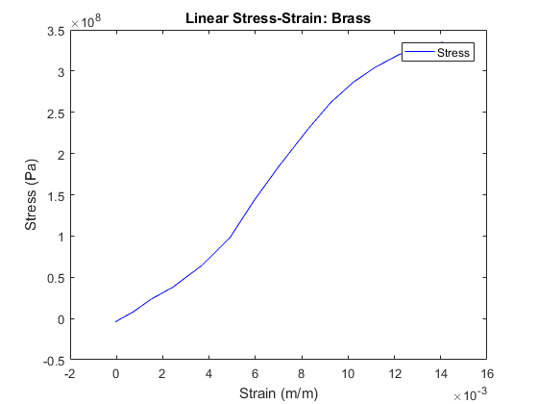

Plot Copper
sC = stressC(1:133);
eC = strainC(1:133);
% Fracture at i = 133
% Ultimate at i = 127
% Proportional Limit i = 17
% .2% Yield i = 20
linC = (2.1011e+10)*eC(1:17)+6.1619e+06;
plot(eC,sC,'b',eC(133),sC(133),'mo',[eC(1:17)+.002],linC,'r--',eC(17),sC(17),'go',eC(20),sC(20),'ro',eC(127),sC(127),'ko')
legend('Stress','Fracture Stress','Linear Slope 0.2%','Proportional Limit','0.2% Yield Stress','Ultimate Stress')
title('Stress/Strain of Copper')
xlabel('Strain (m/m)')
ylabel('Stress (Pa)')
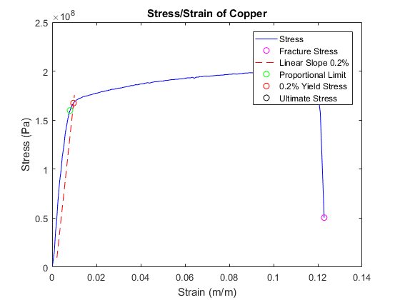

Plot Copper Linear
linC = (2.1011e+10)*eC(1:17)+6.1619e+06;
plot(eC(1:17),sC(1:17),'b')
title('Linear Stress-Strain: Copper')
legend('Stress')
xlabel('Strain (m/m)')
ylabel('Stress (Pa)')
youngC = 2.1011e+10; % Young's mod, slope of linC
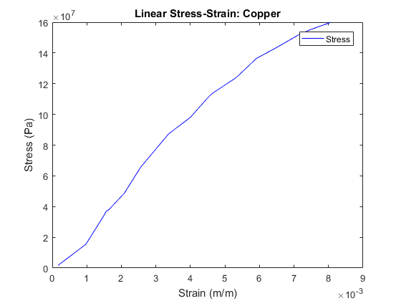

Critical Stress Points
sA = stressA;
% All below values picked by indices chosen from raw data and graphical
% analysis.
% Elongation to Fracture:
efA = posA(392);
efB = posB(235);
efC = posC(133);
% Fracture Stress:
fracA = sA(392);
fracB = sB(235);
fracC = sC(133);
% Ultimate Stress:
ultA = sA(350);
ultB = sB(196);
ultC = sC(127);
% Proportional Limit:
propA = sA(54);
propB = sB(15);
propC = sC(17);
% 0.2% Conventional Yield Stress:
yieldA = sA(64);
yieldB = sB(16);
yieldC = sC(20);

Area under SS Curve
clc
% Toughness, Integral of Entire Curve:
savgA = (stressA(1:391)+stressA(2:392))/2;
% This is the matrix of average heights between each stress value
deA = strainA(2:392)-strainA(1:391);
% This d(eA) is the differential width between each strain value
intA = sum(savgA.*deA);
% The areas are the products of each stress and strain interval,
% the heights*widths, so integral(A) is the exact integral of
% the curve if the stress points were connected by straight
% lines between them. Thus resolution of integration = res of data.
savgB = (sB(1:234)+sB(2:235))/2;
deB = eB(2:235)-eB(1:234);
intB = sum(savgB.*deB);
savgC = (sC(1:132)+sC(2:133))/2;
deC = eC(2:133)-eC(1:132);
intC = sum(savgC.*deC);
fprintf('Modulus of Toughness = \nAluminum: %f MPa\nBrass: %f MPa\nCopper: %f MPa\n\n',intA/10^6,intB/10^6,intC/10^6)
% Resilience, Integral until Elastic Limit:
savgA2 = (stressA(1:53)+stressA(2:54))/2;
deA2 = strainA(2:54)-strainA(1:53);
intA2 = sum(savgA2.*deA2);
savgB2 = (sB(1:14)+sB(2:15))/2;
deB2 = eB(2:15)-eB(1:14);
intB2 = sum(savgB2.*deB2);
savgC2 = (sC(1:16)+sC(2:17))/2;
deC2 = eC(2:17)-eC(1:16);
intC2 = sum(savgC2.*deC2);
fprintf('Modulus of Resilience = \nAluminum: %f MPa\nBrass: %f MPa\nCopper: %f MPa\n',intA2/10^6,intB2/10^6,intC2/10^6)
Modulus of Toughness =
Aluminum: 18.802123 MPa
Brass: 99.598383 MPa
Copper: 22.461038 MPa
Modulus of Resilience =
Aluminum: 1.194189 MPa
Brass: 2.498665 MPa
Copper: 0.738772 MPa

2 Fatigue Cylinders - Bending Stress
% Given values:
L = .028; D = .004; %length,diameter(meters)
F1 = 50; F2 = 60; %forces(Newtons)
S1 = 32*F1*L/(pi*D^3);
S2 = 32*F2*L/(pi*D^3); %Answer in Pascals
fprintf('Cylinder with 50N Load, Bending Stress = %f\nCylinder with 60N Load, Bending Stress = %f\n\n',S1,S2)
Cylinder with 50N Load, Bending Stress = 222816920.328653
Cylinder with 60N Load, Bending Stress = 267380304.394384

S-N Curve
sn1 = (50*.028*32)/(pi*.004^3);
sn2 = (60*.028*32)/(pi*.004^3);
n1 = 90665;
n2 = 28202;
slope = (sn1-sn2)/(n1-n2);
X = [n1,n2];
Y = [sn1,sn2];
semilogx(X,Y)
title('S-N Curve')
xlabel('N-Cycles')
ylabel('Stress (Pa)')
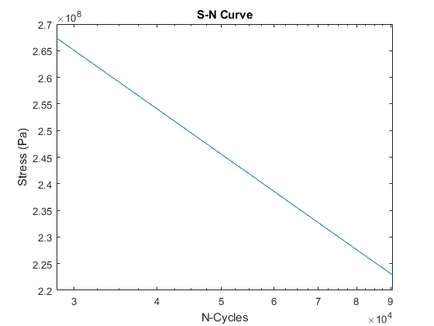
Published with MATLAB® R2016a

